PART I: BEFORE VIEWING
Capitale umano/ Human Capital (look up missing info on IMDb)
Director:___________________
Year: 2013/ 2014

Cast
Character Actor
Dino Ossola Fabrizio Bentivoglio
Serena Ossola
Carla Bernaschi
Massimiliano Bernaschi
Giovanni Bernaschi
Roberta
Luca Ambrosini

1) Analyze the film poster. Who do you imagine the characters to be (occupations, relations/interrelations, challenges/solutions)? What do you think Human Capital will be about? What might be the significance of the film title? Write a minimum of 5 sentences.
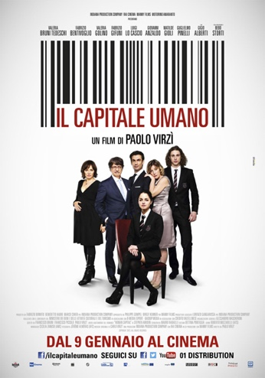

2) Carefully read the abstract of Carlo Testa’s “Crisis – What crisis? The jobless society and Italian cinema in the early 2000s” (pdf on course website). What does Testa propose to illustrate in this article? Write no more than 3 sentences.

PART II: WHILE VIEWING

1) Focus on the three settings listed below and the characters that permanently occupy and temporarily inhabit them. What do these settings and the interactions that occur between characters in them convey about social class? Write at least 2 sentences for each location.

- The Bernaschi residence

- The Ossola residence

- Luca’s apartment/ bedroom

2) Pick one technique/element to focus on: music/sound, camerawork, symbolism/iconography. Describe how this technique/element is used in one scene. Be sure to jot down the minutes so you can re-view it and expand upon this response after viewing the film in its entirety. Write 7 -10 sentences.

PART III: After Viewing

1) Compare and contrast the characters below. Write at least 2 sentences for each pairing/group.

- Dino Ossola vs. Giovanni Bernaschi

- Roberta vs. Serena Ossola vs. Carla Bernaschi

- Massimiliano Bernaschi vs. Luca Ambrosini

2) Why is the film narrative recounted from four different perspectives? Write at least 3 sentences.

3) Which of the seven ‘case studies’ described in Testa’s article (“Crisis – What crisis? The jobless society and Italian cinema in the early 2000s”) is most similar to Human Capital? Explain. Your response in 5-7 sentences.

4) Does the film ending reinforce, modify, and/or completely subvert aspects of work & economy in contemporary Italian society that you read about for class social? Explain your response citing course readings. Write at least 3 sentences.

