ITALIAN SOCIETY IN FILM
ITA 261-1 fall 2021 M/R 3:30-4:45pm

course information

instructor contact
information

Professor: Dr. Lisa Dolasinski

Department of Languages, Literatures & Cultures

dolasinl@newpaltz.edu

Email is the preferred method of
communication. I strive to respond to emails
within 24 hours. Emails received during the weekend and after 9pm may experience
delayed responses.

Virtual Office Hours
M & R 1:00-2:30pm, T 1:00-2:00pm,
& by appointment

Schedule an appointment here: https://calendly.com/dolasinski/office-hours?

Course Number: ITA 261-1 (CRN 1327)
Credit Hours: 4
Class, Days, Times & Location: M&R 3:30-4:45pm, VH 217
Film Screenings: T 5:00-7:50pm, OM 238
Modality: Seated. Attendance Required
Modules: 4 (~ 9 hours each) + homework (average 6 hours per week)

technology
Course Website: https://ldolasinski.wixsite.com/website-6
Twitter (class feed: @italyonscreen) https://twitter.com/italyonscreen

mask policy
As of August 6th, there is an on-campus, indoor mask requirement for everyone, including those who
are fully vaccinated (Overview of fall 2021 COVID-19 policies at SUNY New Paltz). We will continue to
follow and abide by all regulations required by SUNY New Paltz.

technology requirements
- You will need to have access to a computer and high-speed internet
- You will use Webex and other video conferencing platforms for office hours
- You will have to know how to turn the video camera and microphone of your computer on in
Webex & how to navigate Blackboard
- For tech support regarding use of Blackboard contact: blackboard@newpaltz / 845. 257. 4357

goals and objectives

- to analyze and interpret significant themes and events in contemporary Italian society
- to gain literacy in the language and concepts of the analysis of moving image culture
- to compare features of contemporary Italy to those of other regions, cultures, and civilizations
- to clearly analyze premises, synthesize arguments, and evaluate content in appropriate historical, cultural, and film contexts
- to employ a range of critical thinking skills in blog entries, class discussions, and creative research projects


“A film has to be aimed at everyone, a bit of subtle comedy but a bit of crude humor too. The great films are those that speak to the whole audience at the same time.”

- Sydney Sibilia

Smetto quando voglio (I Can Quit Whenever I Want, Sydney Sibilia, 2014)

what we’ll watch
course
description

Making use of a multidisciplinary approach, this course will explore how contemporary Italian cinema has mirrored, responded to, and, in some cases, anticipated cultural and social transformations of Italian society. A central aim of this course is to better understand present-day Italy and Europe, by viewing and discussing those films produced in Italy that most reflect the nation, its culture, and its society. A secondary objective will be acquiring the appropriate language and tools necessary to analyze and discuss media. Topics will include work & the economy, organized crime & outlaws, migrants & second-generation Italians, and queer identities.

work & the economy
- Il capitale umano (Human Capital, Paolo Virzì, 2014)
- Smetto quando voglio (I Can Quit Whenever I Want, Sydney Sibilia, 2013)
- Quo vado? (Gennaro Nunziante, 2016)
organized crime & outlaws
- Gomorra (Matteo Garrone, 2008)
- La paranza dei bambini (Piranhas, Claudio Giovannesi, 2019)

migrants & second-generation Italians
- Terraferma (Emanuele Crialese, 2011)
- La sconosciuta (The Unknown Woman, Giuseppe Tornatore, 2006)
- Bangla (Phaim Bhuiyan, 2019)

queer identities
- Call Me by Your Name (Luca Guadagnino, 2017)
- Io e lei (Me, Myself and Her, Maria Sole Tognazzi, 2015)
- Season 2 of SKAM Italia (TIMvision, 2018)


Il capitale umano (Human Capital, P. Virzì, 2014)


Smetto quando voglio (I Can Quit Whenever I Want, S. Sibilia, 2013)

tips for success

use the viewing guides provided on the course website

- keep in mind that each film has been selected because it corresponds with a particular socio-cultural aspect of contemporary Italian society

- remember that one of our goals is to acquire the tools and vocabulary necessary to talk clearly about film and how a film works; use them as much as you can!

- if you are having trouble focusing on non-plot elements of a film, try watching with the volume off

- break larger assignments/ assessments into smaller ‘chunks’; time management is essential for success

- if you don’t understand a concept or term, ask!

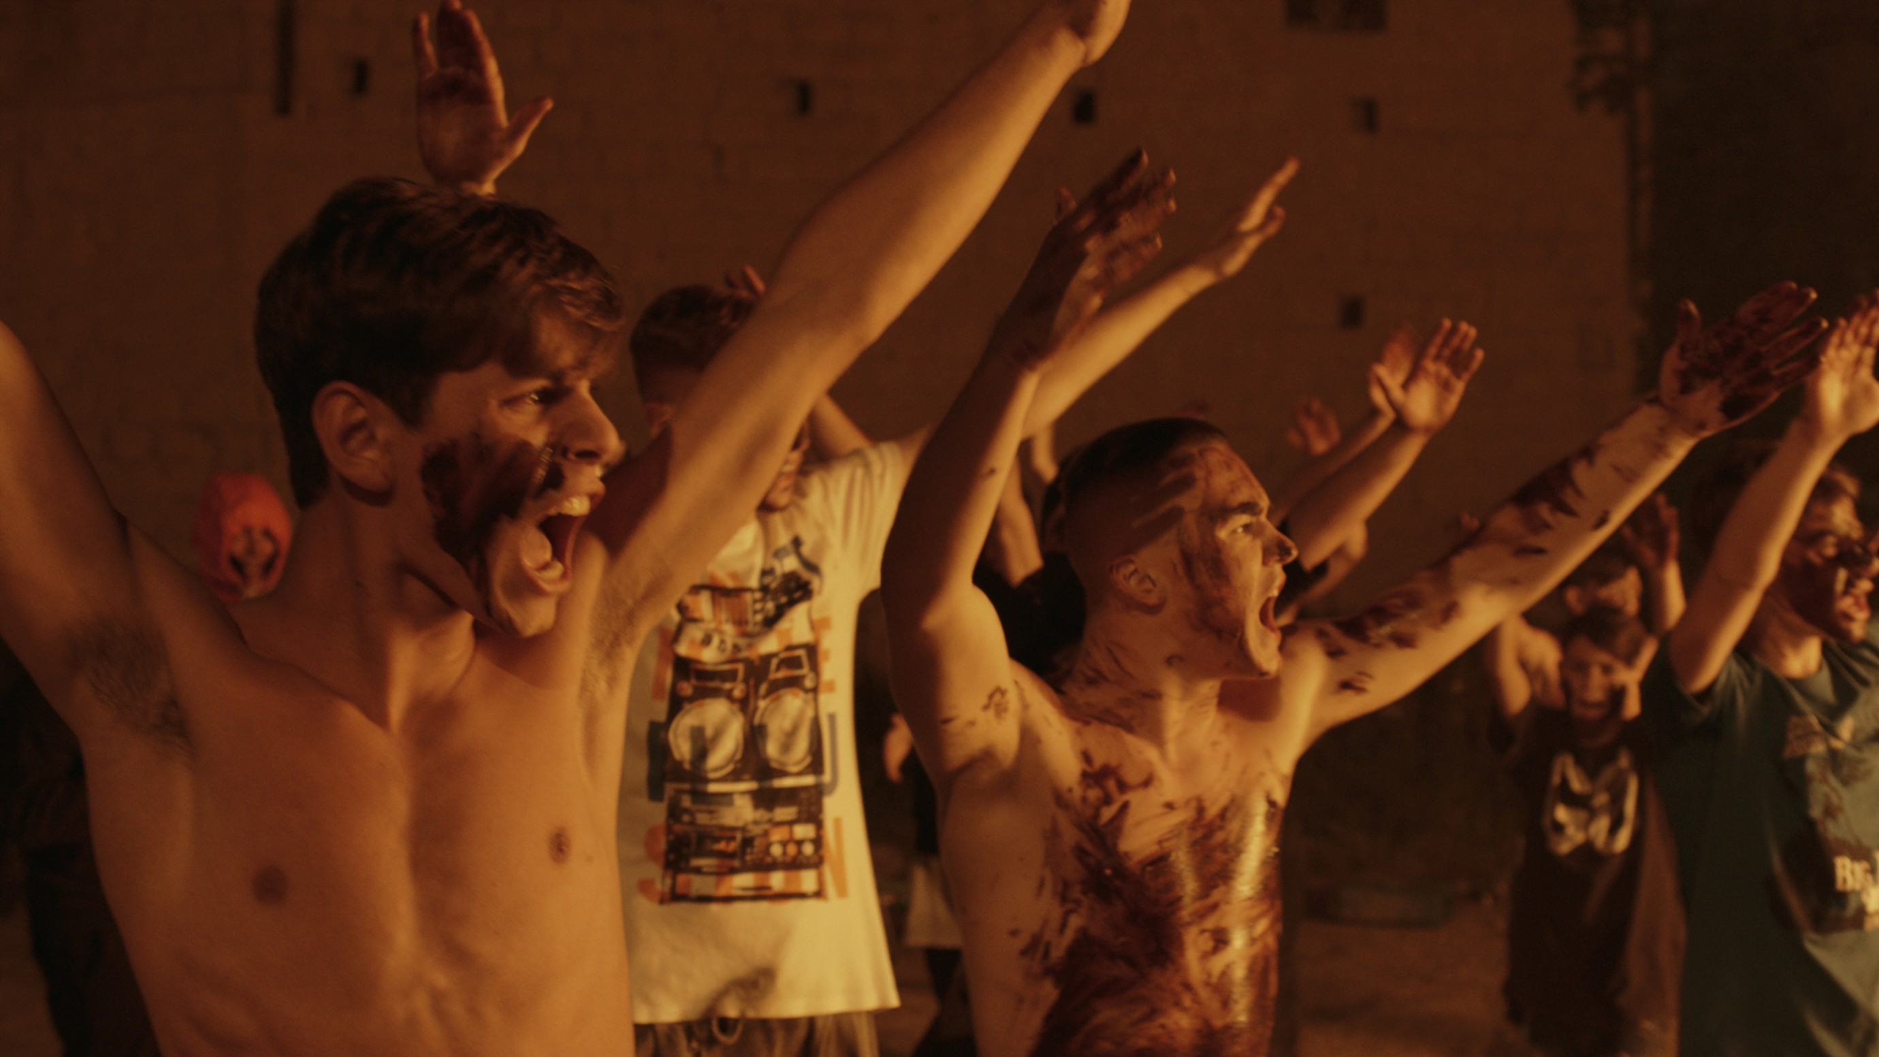

La paranza dei bambini (Piranhas, C. Giovannesi, 2019)

class schedule
day-to-day assignments are posted on the course website (detailed calendar)

WEEK | DAYS | TOPIC/ FILM | MAJOR ASSIGNMENTS/ ANNOUNCEMENTS
1 | 23, 26 aug | Course introduction
2 | 30 aug  2 sept | Module 1: work & the economy  Il capitale umano (Human Capital, P. Virzì, 2014) | Scene Analysis: Explanation, Example, Sign up (2 September)  Viewing guide 1- due by midnight on Friday, September 3 on BB
3 | 6, 9  sept | Module 1: work & the economy  Smetto quando voglio (I Can Quit Whenever I Want, S. Sibilia, 2013) | 6 September- Labor Day, No classes in session  Viewing guide 2- due by midnight on Friday, September 10 on BB
4 | 13, 16  sept | Module 1: work & the economy  Quo vado? (G. Nunziante, 2016) | Viewing guide 3- due by midnight on Friday, September 17 on BB
5 | 20, 23  sept | Module 2: organized crime & outlaws  Gomorra (Matteo Garrone, 2008) | Viewing guide 4- due by midnight on Friday, September 24 on BB
6 | 27, 30  sept | Module 2: organized crime & outlaws  La paranza dei bambini (Piranhas, C. Giovannesi, 2019) | Viewing guide 5- due by midnight on Friday, October 1 on BB
7 | 4, 7  oct | Course review + Module 3: migrants & second-generation Italians | Meme / TikTok (midterm review), 4 October  Explanation: UNESSAY + annotated bibliography (final)  Library Research Session, 7 October  Viewing guide 6- due by midnight on Friday, October 8 on BB
8 | 11, 14  oct | Module 3: migrants & second-generation Italians  Terraferma (E. Crialese, 2011) | 11 October- Indigenous Peoples’ Day / Columbus Day, No classes in session  12 October- Fall Break, no film screening
9 | 18, 21  oct | Module 3: migrants & second-generation Italians  La sconosciuta (The Unknown Woman, G. Tornatore, 2006) | Viewing guide 7- due by midnight on Friday, October 22 on BB
10 | 25, 28  oct | Module 3: migrants & second-generation Italians  Bangla (P. Bhuiyan, 2019) | In-class session: Unessay proposal (bring to class completed)- October 25  Viewing guide 8- due by midnight on Friday, October 29 on BB
11 | 1, 4 nov | Module 4: queer identities  Call Me by Your Name (L. Guadagnino, 2017) | Viewing guide 9- due by midnight on Friday, November 5 on BB
12 | 8, 11  nov | Module 4: queer identities  Io e lei (Me, Myself and Her, M. Sole Tognazzi, 2015) | Unessay proposal- due by midnight on Friday, November 12 on BB  Viewing guide 10- due by midnight on Friday, November 12 on BB
13 | 15, 18  nov | Module 4: queer identities  Season 2 of SKAM Italia (TIMvision, 2018) | Viewing guide 11- due by midnight on Friday, November 19 on BB
14 | 22, 25  nov | Course conclusions | [Un]essay presentations (final)- November 22, 29 & December 2 (during class)  24-26 November- Thanksgiving Recess, No classes in session  Please complete SEIs: November 24- December 8
15 | 29 nov  2 dec | Course conclusions | [Un]essay presentations (final)- November 22, 29 & December 2 (during class)  Please complete SEIs: November 24- December 8

[Un]essay + annotated bibliography + final reflection due by 4:45pm on Monday, December 13



Bangla (P. Bhuiyan, 2019)


“Representation FOR stereotypes is a huge problem because it flattens and reduces our identities to simple cardboard shapes. But the representation OF stereotypes is not bad: to condemn it would represent a further risk of discrimination, more subtle but equally terrifying. Stereotypes and clichés exist because they originate from the observation (albeit limited and limiting) of “common” characters in others: what must be rejected is the superficial, instrumental, prejudicial use of these characters, but not the very fact that they have a place in people.”

- Pietro Turano, actor in SKAM Italia & Vice President of Arcigay Roma

SKAM Itaiia, season 2 (TIMvision, 2018)

more about Italian at New Paltz

We offer courses in the language, literature, film, and culture of Italy and Italians in the world. If you are interested in learning more about courses in the Italian Studies Program, ask me about our course offerings.

course policies
grading scale
assessment and grading
Late work will be accepted after the submission deadline. It will be penalized 5% per day of lateness. Final grades will be based on the following components:

Attendance, preparation & participation
10%
Viewing guides
instructions on course website
30% (3% x 10)
Scene analysis
instructions & rubric on course website
15%

Meme / TikTok (midterm review)
instructions on course website
10%

[Un]essay (final)
instructions & rubric on course website
20%

Annotated bibliography
instructions & rubric on course website
10%

Final reflection
instructions on course website
5%

A 94-100 A- 90-93 B+ 87-89

B 84-86 B- 80-83 C+ 77-79

C 74-76 C- 70-73 D+ 67-69

D 64-66 D- 60-63 F below 60

Communication

It is the student’s responsibility to regularly check her/his university email address, which is going to
be the only email address used for classroom correspondence. Daily homework, resources, and any
changes to the syllabus with be communicated in class and posted on the course website.

Attendance

Regular class attendance is a student obligation, and students are responsible for all work, including
film screenings, homework assignments, and assessments. Two unexcused absences are permitted
during the entire semester. Each absence after the permitted ones will result in an automatic
deduction of 2 percentage points from your total participation grade at the end of the semester. 3
late arrivals or leaving class early = 1 absence. Repeated absences will seriously impact your final
grade; more than 10 unexcused absences will result in a failing grade for the course. You should
try not to miss any lessons, but if absolutely necessary, it is your responsibility to determine work missed in class and what is expected for the next class meeting.

Preparation & Participation

Presence and participation are mandatory. Please be respectful to your classmates; extend grace and patience to peers and your instructor as we navigate this course together.

Readings and discussion questions must be completed before class. They are posted on the course
website (detailed calendar). I reserve the right to randomly collect students’ responses to
discussion questions and adjust preparation grades accordingly (i.e. incomplete/insufficient responses will negatively impact students’ grades).

You are allowed TWO excused absences. Beyond two unexcused absences, a student’s final
participation grade will be decreased by 2 percentage points per absence. Repeated unexcused
absences will seriously impact the final grade; more than 10 unexcused absences will result in a failing grade for the course. Cases of illness or emergency will be handled on an individual basis. Please contact me as soon as possible so that appropriate actions can be taken.

Extra Credit

You can earn extra credit by tweeting at and/or replying to tweets on our class Twitter feed
(@italyonscreen)
10 posts and/or replies= 3 bonus points
8 posts and/or replies= 2 bonus points
5 posts and/or replies= 1 bonus point

* Extra credit can be earned only if all course assignments assessments are submitted on time.

Academic Integrity:

campus resources & policies

Academic Assistance

The Center for Student Success (CSS) provides students with peer based academic skills coaching and advising, online tutoring, subject tutoring
in historically difficult courses, and writing support across the curriculum. CSS services are intended to enhance, not supplant, other forms of
collaborative learning. The Center also houses the campus-wide student success system, powered by Starfish. Please visit our website for syllabus
statements regarding CSS services and encourage your students to visit the CSS website to learn more about the services available.

Academic Integrity & Plagiarism

Students are expected to maintain the highest standards of honesty in their college work. Cheating on any assignments or assessments will
result in prompt academic disciplinary action. All work must represent a student’s individual effort. Plagiarism will not be tolerated. Plagiarized
work will automatically receive a 0 and the incident will be reported to the Department Chair, Academic Dean, and Associate Dean for Student
Affairs as described at http://www.newpaltz.edu/ugc/policies_integrity.html

Accommodations

Students needing classroom and/or testing accommodations related to a disability should contact the Disability Resource Center (Haggerty Administration
Building, Room 205, 845-257-3020) as close as possible to the beginning of the semester. The DRC will then provide students’ instructors with
Accommodation Notifications verifying the need for accommodations. Specific questions about services and accommodations may be directed to Deanna
Knapp, Assistant Director (knappd@newpaltz.edu) or Jean Vizvary, Director (vizvaryj@newpaltz.edu).

Add Drop Policy and Academic Calendar

The last day for course withdrawal is October 29. Partial-refund and other key deadlines are listed on the Academic Calendar. The mid-point of the
semester is October 10.

Black Solidarity Day

Students who will not be attending class on Monday, November 1, to take part in Black Solidarity should notify their professors ASAP to determine a path to make up missed work. They will not be held accountable for absence on that day.

Computer and Network Policies

Users of New Paltz’s computer resources and network facilities are required to comply with the Acceptable Uses and Privacy Policy and other institutional policies related to computer and internet access and usage.

Delays and Emergency Cancellations Policy

The instructor will follow New Paltz’s guidelines regarding campus delays and emergency cancellations, as highlighted at http://www.newpaltz.edu/emergency/policy.html. Information about campus closing or delays can be obtained by calling 257-INFO or checking the
SUNY New Paltz webpage. It is strongly encouraged that students register for the campus’s NPAlert emergency text-message service
(http://www.newpaltz.edu/npalert/). Commuters who do not feel safe driving on the roadways in case of inclement weather when classes are not
delayed/canceled, will need to make their best judgment about whether to travel or not.

Identity Verification Policy

New Paltz’s Online Identity Verification Policy is designed to verify that students enrolled in our online courses and/or programs are the ones who take the courses, complete the programs, and receive the academic credit. The complete policy is published in the Undergraduate Catalog.

Military Obligations

In partnership with academic and professional faculty, the Office of Veteran & Military Services (OVMS) makes every effort to provide reasonable accommodations for individuals who must be absent due to military obligations. The student and faculty member must agree that the length of the
absence is reasonable for the type and structure of the course and must devise a written plan detailing expectation for successful course completion.
Students who actively participate in the United States Military Reserve or National Guard are highly encouraged to provide each faculty member, as well
as the OVMS, a copy of their Reserve and/or National Guard schedule during the first week of class each semester.
Note: The undergraduate student military leave policy and the graduate student policy are available online for reference.

Religious Observations
New Paltz faculty complies with New York State Education Law (Chapter 161, Section 224). Students who plan on being absent to observe a religious holiday will not be accountable for their absence that day. They must inform their professors ASAP to determine a path to make up missed work.

SEI

Student Evaluations of Instruction (SEIs) will be available online during the open period from November 24 - December 8 for all courses with five (5) or

more people. You are invited to provide constructive feedback via the relevant link on my.newpaltz.edu website. I value your input.

Technical Support

For technical support, including account and system related issues, go to support.newpaltz.edu to visit our knowledge base or submit a support ticket
24 hours a day. The Service Desk is available during business hours (see support.newpaltz.edu) for live support (HUM 103. Phone: 845-257-4357.
Email: servicedesk@newpaltz.edu).

Title IX and Related Policy

Gender discrimination, sexual harassment, sexual assault, sexual violence, stalking, and power-imbalanced sexual/romantic relationships between faculty
and students are strictly prohibited within the SUNY New Paltz community. We encourage students to report, confidentially discuss, or raise questions and concerns regarding potential violations. Reports can be made to the Title IX Office, the department chair and/or the dean of your school. For information
on Title IX reporting and support, visit https://www.newpaltz.edu/titleix/. The College’s Consensual Relationship Policy can be found at HR Policies.

