PART I: BEFORE VIEWING
La paranza dei bambini/ Piranhas (look up missing info on IMDb)
Director:___________________
Year:

Cast
Character Actor
Nicola
Letizia
Briatò
‘O Russ
Lolipop
Tyson
Biscottino
Agostino
Cristian
Limone
Nicola’s mom

1) Analyze the film poster. Who do you imagine the characters to be (relations/interrelations, challenges/solutions)? What do you think Piranhas will be about? What might be the significance of the film title? Write 5-7 sentences.
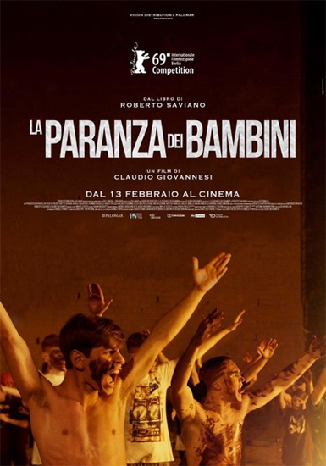

2) Watch the interview with Roberto Saviano. Why does Saviano say that he doesn’t care about being subjective? Do you think his approach is effective for conveying an authentic image of the mafia? Why or why not? Write a minimum of 5 sentences.

PART II: WHILE VIEWING

1) Pick one technique/element to focus on: music/sound, camerawork, symbolism/iconography. Describe how this technique/element is used in one scene. Be sure to jot down the minutes so you can re-view it and expand upon this response after viewing the film in its entirety. Write 7-10 sentences.

PART III: After Viewing

1) In her review of Piranhas, film critic Chiara Borroni states that children who grow up in the Spagnoli neighborhood of Rione Sanità (click here for a short video) must choose between two ‘existential categories’: who is good and who is bad (‘che è 'o bbuono e chi è 'o malamente’). Do you agree that these are the only options presented to the characters in Piranhas? Can you think of any examples of ‘moral ambiguity’? Write 5-7 sentences.

2) Does this film remind you of Gomorrah? Why or why not? Do you notice any elements/conventions of neorealism and noir? List them below.

3) Do you think this film (de)glamorizes organized crime? In your opinion, what kind of impact might this film have on adolescents in Italy- especially those that grow up in Spagnoli? Write a minimum of 3 sentences.

4) How has this film modified your understanding of organized crime in Italy? What did you find most surprising about the these adolescent mafiosi? Write a minimum of 5 sentences.

