Instructions

For our midterm review, you will create and present either a meme or a 30-60 second TikTok on a film screened in class. Your meme / TikTok must capture themes discussed in class (contemporary Italian society: the economy, organized crime). You may choose the film/ film protagonist you would like to present on within your group of 5. However, you may not present on the same film/ film protagonist of your scene analysis. If you decide to use TikTok, you will either need to make your video public or download a copy of your video that can be submitted on Blackboard.

In addition to creating a meme/ TikTok you must prepare a 200-250 word explanation of your meme/ TikTok, referencing class readings and discussions. You’ll share your meme/ TikTok in class and submit it on Blackboard.

Memes provide rhetors on the Internet with a visually engaging device for generating discussion.

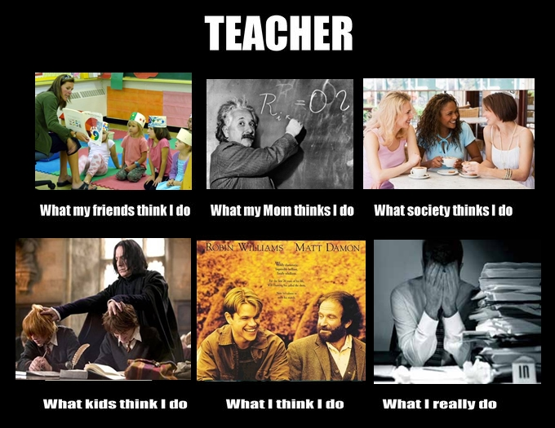

TikTok is an app for making and sharing short videos.

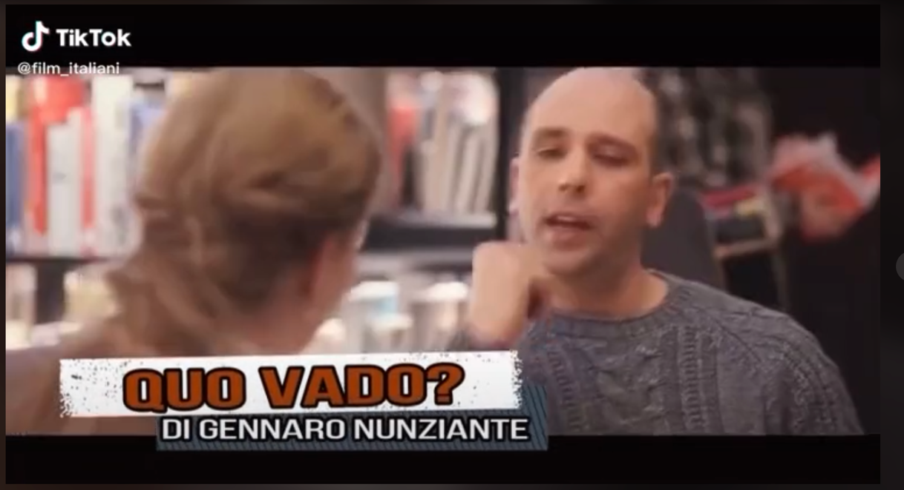



Technology
You may use technology/resources you are familiar with; however, I would encourage you to use Canva for memes (https://www.canva.com/). Canva is a free graphic design platform that provides templates and uses a simple drag and drop interface.

Films
Il capitale umano (Human Capital, P. Virzì, 2014)
Smetto quando voglio (I Can Quit Whenever I Want, S. Sibilia, 2013)
Quo vado? (G. Nunziante, 2016)

Gomorra (Matteo Garrone, 2008)

La paranza dei bambini (Piranhas, C. Giovannesi, 2019)

Grading Criteria
25% Following directions
- respects time limit/ assignment length, submits materials on time, participates in midterm review
60% Insights
- meme/ TikTok is connected to historical/ filmic context studied in class
- includes explanatory paragraph that references class readings/discussions
- uses at least 2 film terms in explanatory paragraph
15% Engagement + Creativity
- facilitates peer-peer discussion

